In the web services terms, REpresentational State Transfer (REST) is a stateless client-server architecture in which the web services are viewed as resources and can be identified by their URIs. Web services client uses that URI to access the resource.
It consists of two components REST server which provides access to the resources and a REST client which accesses and modify the REST resources.
In the REST architecture style, clients and servers exchange representations of resources by using a standardized interface and protocol. REST isn't protocol specific, but when people talk about REST they usually mean REST over HTTP.
The response from server is considered as the representation of the resources.
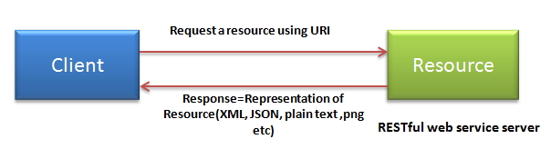

REST allows that resources have different representations, e.g.xml, json etc. The rest client can ask for specific representation via the HTTP protocol.
HTTP methods :
RESTful web services use HTTP protocol methods for the operations they perform. Methods are:
GET: It defines a reading access of the resource without side-effects. This operation is idempotent i.e. they can be applied multiple times without changing the result
PUT : It is generally used for updating resource. It must also be idempotent.
DELETE : It removes the resources. The operations are idempotent i.e. they can get repeated without leading to different results.
POST : It is used for creating a new resource. It is not idempotent.
Idempotent means result of multiple successful request will not change state of resource after initial application
For example:
Delete is idempotent method because when you first time use delete, it will delete the resource (initial application) but after that, all other request will have no result because resource is already deleted.

Post is not idempotent method because when you use post to create resource, it will keep creating resource for each new request, so result of multiple successful request will not be same.

